- Inversion
  - Brute Force
    - It counts by saying that if I have 2 index’s i and j where j>i, if array[i]>array[j] then increment the inversion count.
    - This is correct because by the definition of an inversion, if j>i, an inversion exists if A[i]>A[j].
    - The complexity is O(n^2) because the total amount of elements it counts through is n(n-1)/2, which simplifies to O(n^2). This is thanks to the double for loop.
    - No asserts are raised while running the Brute Force algorithm.
  - Merge_Count
    - It counts inversions through a merge sort method. While merging a left and right array, if the element in the right array is less than the element in the left array, it must also be less than every other element in the left array so inversions += len(left_array)-left_index.
    - If an element causes n inversions to happen, then at some point it may be combined into an array where there are m inversions it creates. That means that n-m inversions still exist, and it must come across those at some point since that element will be chosen to be the next element to add to the merged array over n-m elements in the left array.
    - The complexity is O(nlogn) since it is a standard merge_sort algorithm and because inversions are able to be counted when adding the next element into the array, inversions do not increase the big O running time. T(n) = 2T(n/2)+O(n)
    - No asserts are raised while running the Merge_Count algorithm.
  - The point at which merge is faster than brute force is typically with size in the 60’s. This can of course change from run to run thanks to hardware and scheduling. Merge can be slower because of the overhead that recursion causes while brute force has a low overhead. For large n, merge sort is significantly faster than brute force. At n=20,000, merge is about 162.7 times faster than brute force.

- Coin-Change
  - Greedy
    - It works by picking the largest coin denomination it can with each loop and returning a list of coins used.
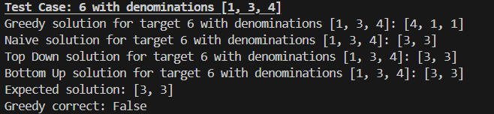
    - Not exactly optimal. Target = 6 and denominations = {1,3,4} causes greedy to pick {4,1,1} where optimal is {3,3}.
  - Naïve
    - Works by doing recursive calls where the base case is either target_amount == 0 or target_amount < 0. It then picks the best at each layer.
    - Can find the optimal answer, but runs in O(K^A) where K is the number of coin denominations and A is the target value. This is because the smallest denomination is 1, so with a target value of A, there would have to be A layers of recursion to hit the base case. The testing showed that it doesn’t fully match this because when recursive calls are made, only 1 of those calls gets turning into the branch that continues down to A layers with other smaller branches. It actually tends to follow a 1.5 times increase. That still shows that it doesn’t follow a linear or polynomial increase as A increases, but it follows an exponential increase.
  - Top Down with Memoization
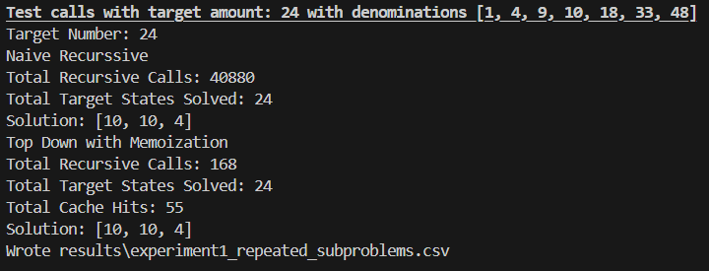
    - Works very similarly to Naïve but adds in a dictionary and adds a base case. If the target value you are looking for is a key in the dictionary, return the value of dict[key]. We also modified it so that it put the best solution at every call into the dictionary. This allows it to not have to recurse all the way down to the very bottom every time.
    - The running time is O(KA) where k is the number of coin denominations and A is the target value. This is because every target value <= A is found because 1 is in the denomination list and for each target value it iterates over every coin denomination.
  - Bottom Up with Memoization
    - Bottom Up works in a similar way where it finds the optimal coin amount at lower target values up to the target value and loops over every coin denomination at those values.
    - It runs in O(KA) time because it loops over every denomination and every integer value between 1 and A.

